**TC50 SSID Change Instructions**

* Power on TC50 → Tap “Setup”→ Tap “Configure ECG Network Settings”→ Tap “Wireless Network”→ Tap “Configure”→ Tap “Admin Login”→ Enter password “SUMMIT” → Tap “Profile” → Tap SSID → Enter the new SSID “NSWHEALTH” →  
  Tap credentials → **Add** to front of the current username “HNEAHS\” → Tap “Commit” to change. →

Exit the windows one by one saving changes when prompted.

* Tap Setup

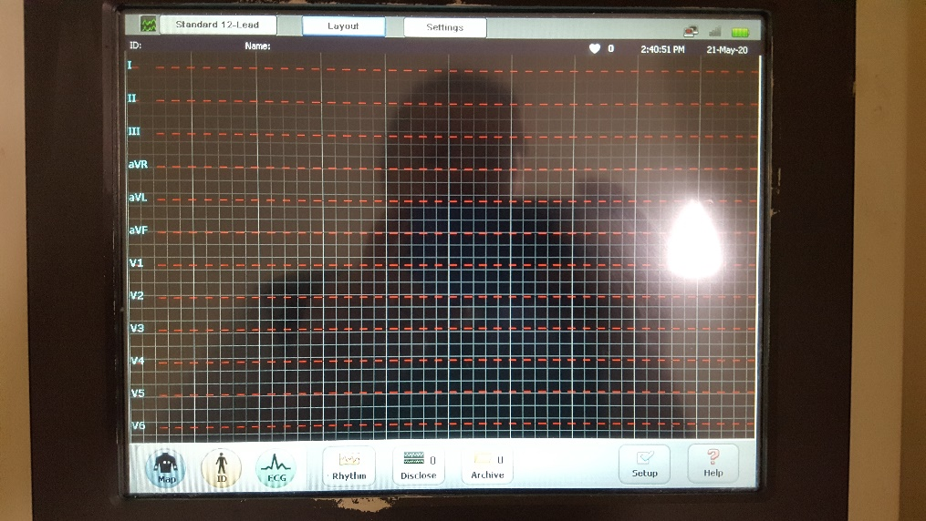

* Enter Configure ECG Network Settings

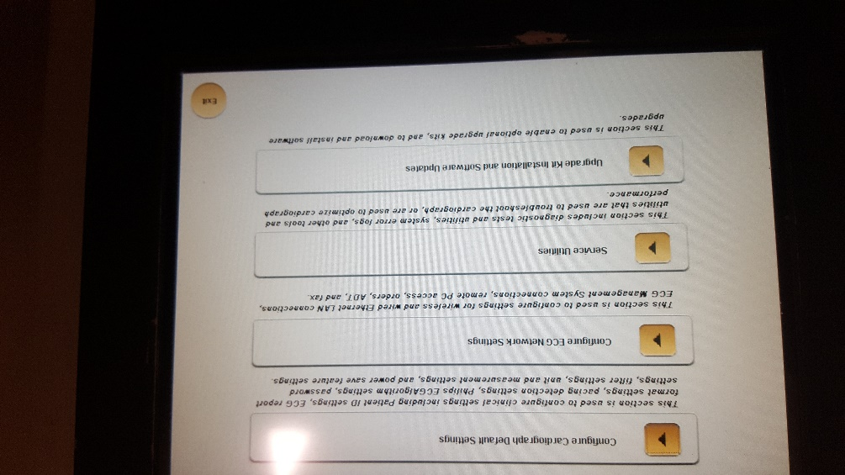

* Enter Wireless Network

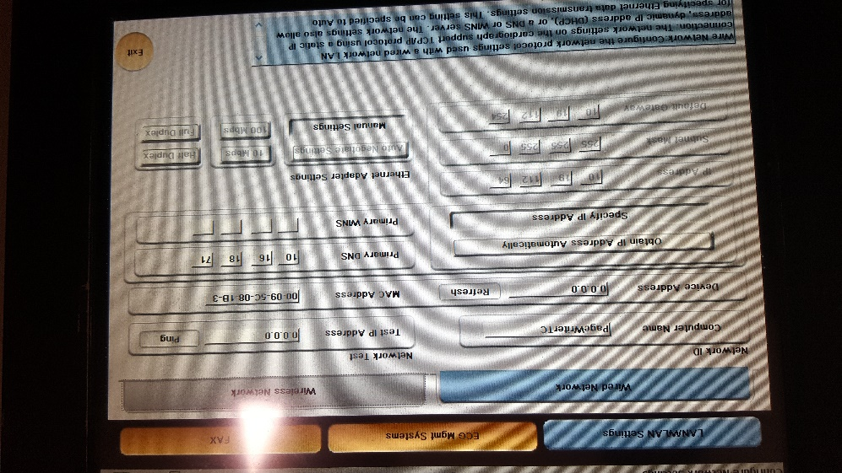

* Select Configure
* Select Admin Login and enter password “SUMMIT”

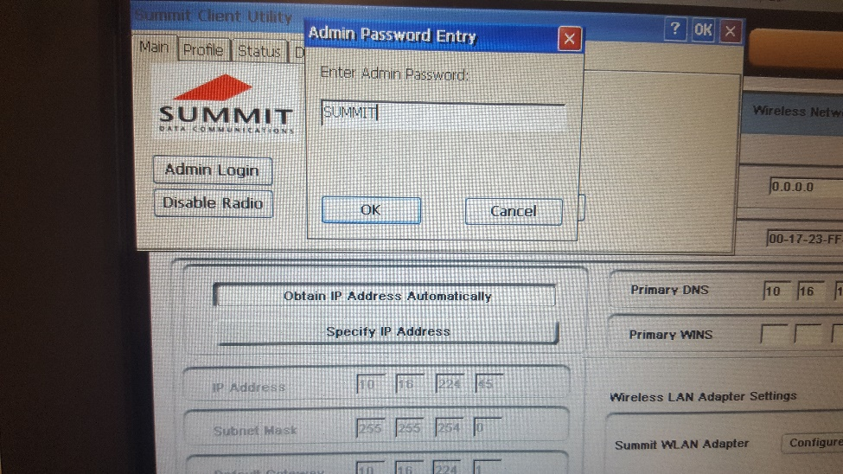

* Go to profile tab, select SSID and enter the new SSID “NSWHEALTH”.

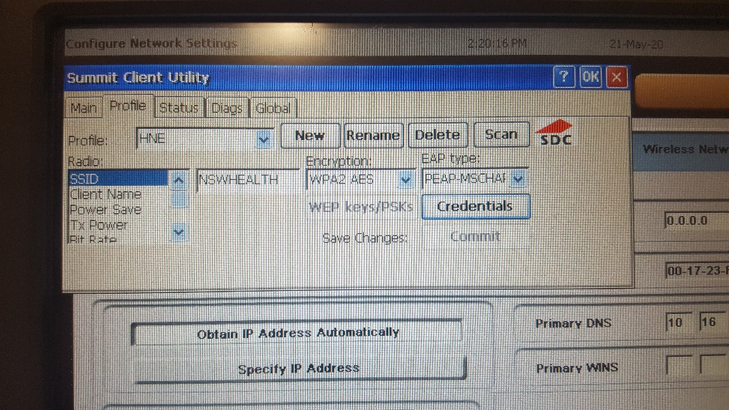

* Click on credentials and **add** to front of the current username “HNEAHS\” and click “Commit” to change.

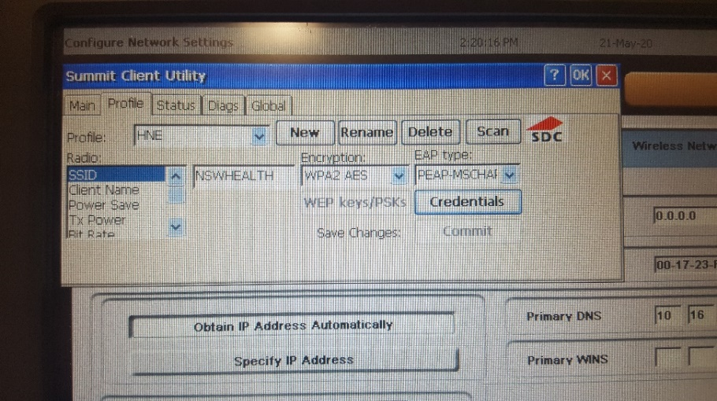

* Exit the windows one by one saving changes when it asks you to.